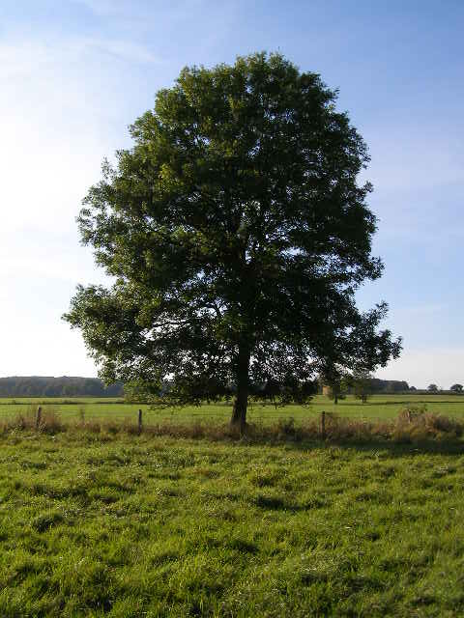
Cam Vale Group Parish Council and Glanvilles Wootton Parish
Parishes’ Field Management Committee 8TH MAY 2017 – 7.00 pm
Glanvilles Wootton Village Hall
Present: Martin Preston, Clive Jesty, Edwin Parrott, Richard Clark, Brenda Evans, Angela and Graham Sargent, the Clerk.
1. Apologies for absence – Fiona Wilson, Mike Sandy
2. Minutes of the meeting held on 9th April 2015 – unanimously agreed.
3. Matters arising – no matters arising.
4. Chairman’s report
As you all know the field has now been let to Graham Sargent on a formal lease allowing us a much greater freedom to address the increasing problems of ingrowing hedges and rush growth in the grass.
Graham has done a fantastic job in leading the management of the field and anyone taking a stroll down there will see an immediate difference.
In Autumn of 2015 the overgrown hedges were cut back from the fence by Derek Eastment who took on a difficult job and tackled it admirably. The few areas he couldn’t manage, owing to the size of the overgrowth, were tidied up in the Spring of last year by Colin Arnold. Once the Hedges were all trimmed Graham took on the job of strengthening the fencing himself. Chestnut stakes were driven in in-between the existing stakes where needed in order to keep the boundary secure. The three strand barbed wire fencing has also been supplemented with sheep fencing. The thinking behind this is as follows. The reliance on cattle grazing, imposed by the original fencing, has led to the wet ground being trodden up, providing the ideal conditions for the rushes which have begun to dominate. Sheep fencing will allow us greater freedom to graze with a regime that will bring the grass and rushes into better balance.
Our first priority last Summer was to get the grass eaten off. However, there were difficulties arranging a grazier in the first instance and by the time Phil Harris put sheep in the grass growth was a little too long for them to make a huge difference.
Later in the season Graham cut the grass more than once as a means to start the process of rush control. This seems to have had a good effect and it is hoped that a regular regime of trimming and grazing will eventually bring about a favourable grass rush balance.
In conclusion the field is in the best shape it has been for several years and it is hope that, during the next few years, we can hone a regime of grazing and management that will allow us to balance an agriculturally useful resource with increasing wildlife interest.
5. Treasurer’s report
Finally, on a sadder note, the passing of Lorna Powell last year has left the committee without the treasurer who has kept our finances ever since the committee’s creation. Last year I approached Mrs Brenda Evans who has agreed to take on the role.
The finances are balanced at £1952, having spent money on fencing £1400 and professional fees. Next year’s expenses should be lower
6. Election of chairman and committee members
It was resolved that Martin Preston would continue as Chairman for the forth-coming year with Graham Sargent as Vice Chairman. Unanimously agreed.
It was resolved that Brenda Evans be elected as Treasurer for the forth-coming year. Proposed: Graham Sargent, 2nd: Edwin Parrott. Unanimously agreed.
It was resolved that the Committee members would include:-
Fiona Wilson, Clive Jesty, Edwin Parrott, Richard Clark, Brenda Evans and Ken Barton Proposed: M Preston. 2nd Clive Jesty unanimous.
7. Approval of payments
  - Annual distribution between parishes = no distribution for 2017.
  - £340 for insurance was agreed as insurance is due on 4/5/17. Further enquiry to be made with regards to alternative, cheaper insurance. Martin Preston to send information to the Clerk to enquire to see if Cam Vale insurance can cover the field. Graham Sargent to enquire of his insurance company. Decision on cover can be agreed via email.
8. Field letting arrangement for 2017 will continue as per the agreement with Graham Sargent.
9. Management and maintenance program for the field
Graham Sargent gave an overview of the expenses and management of the field. Rushes are looking better, but there is not much flower content. The grass has improved with an early cut and the option for sheep grazing is kept. It is anticipated that there will be no land based subsidies in the future so there needs to be applications for an environment scheme - deadline September, asked that Martin Preston investigate.
10. Any other business - none

